

# Weapon menu Ls (Left side) and Rs (Right side) dynamic indexes

|  |  |
| --- | --- |
| WeapMenu_Ls_WeaponId(playerid, **INDEX**) | WeapMenu_Rs_WeaponId(playerid, **INDEX**) |

***Above arrays return weapon id:***

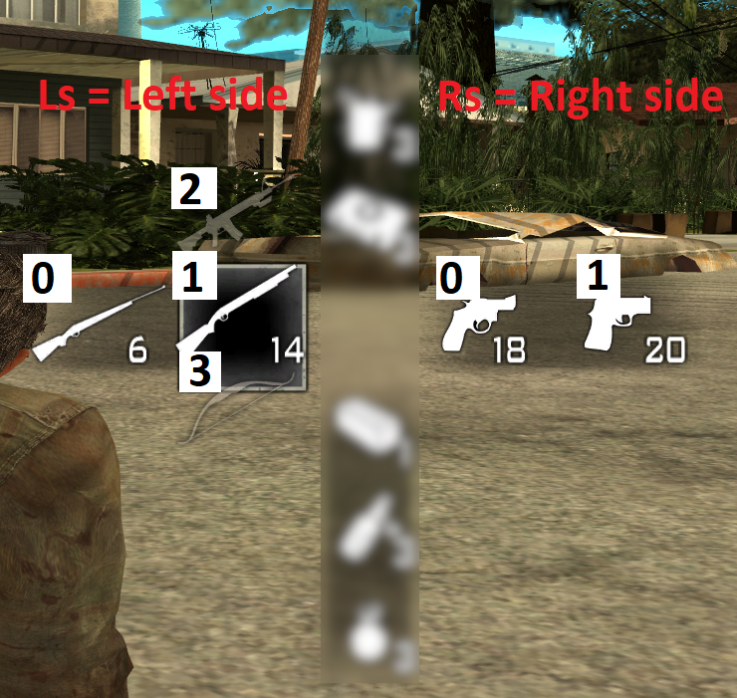

Right side of the weapon menu additionally has index 2 which is currently not used at all (there should be a Shorty weapon, but it crashes the game when shot – issue related to SA-MP+ plugin)